HouseBroker: House Price Recommendation System
Krishna Vamshi Mada
COMP-699-A Professional Seminar
Spring 2026

Executive Summary
The HouseBroker system is designed as a predictive analytics application that supports property price evaluation using structured housing data. In real estate decision-making, property valuation depends on multiple interacting variables such as location, size, and accessibility. Traditional approaches often rely on manual comparison of similar listings, which may not capture the combined influence of these factors. HouseBroker addresses this limitation by applying regression-based modeling techniques to generate data-driven price estimates derived from historical housing datasets.
The system enables an End User to input property attributes and receive an estimated price, a recommended price interval, and a classification indicating whether the property is underpriced, fairly priced, or overpriced. These outputs are generated through a structured workflow that includes input validation, feature alignment, model execution, and result interpretation. In addition to prediction, the system provides insight into influential variables, allowing users to understand how different features contribute to the estimated price. This focus on interpretability ensures that results can be used as analytical guidance rather than opaque outputs.
From a system design perspective, HouseBroker follows an object-oriented approach supported by UML-based analysis models. The system defines clear interactions between components such as input processing, regression modeling, pricing analysis, and result presentation. Administrative functionality is also included, allowing a Model Administrator to manage datasets, train regression models, evaluate performance using metrics such as RMSE and R², and activate models for prediction tasks. These design elements ensure that the system remains modular, maintainable, and aligned with defined requirements (Dennis et al., 2020).
The implementation of HouseBroker is carried out using Python in a Jupyter Notebook environment, leveraging libraries such as Pandas for data processing and Scikit-learn for regression modeling. This choice supports efficient handling of structured datasets, feature processing, and model evaluation. The system demonstrates how machine learning techniques can be integrated into a decision-support application while maintaining transparency and interpretability in the analytical process (Géron, 2022).
In summary, HouseBroker illustrates how predictive modeling can be applied to real estate valuation by transforming raw housing data into structured, interpretable insights. The system emphasizes a clear relationship between input features, analytical processing, and output results, thereby supporting informed decision-making in property evaluation contexts.

Table of Contents
1. HouseBroker: House Price Recommendation System 1
2. Executive Summary 2
3. Table of Contents 4
4. Introduction 6
4.1 Background on Company 6
4.2 Problem Description 7
5. System Proposal 8
5.1 System Request 8
5.2 Requirements Definition 12
5.3 Functional Requirements (Customer-Oriented) 12
5.4 Non-Functional Requirements 13
6. Functional Model — Use Case Descriptions 15
6.1 Use-case diagram 15
6.2 Use-Case Descriptions 17
6.3 Activity diagram 26
7. Behavioral Model 28
7.1 Sequence diagram 28
8. Design Model (Class and Method Design) 32
8.1 Package Diagram 32
8.2 Design Model —Contract 35
8.3 Method Specification 35
9. Structural Model 36
9.1 Class Diagram 36
9.2 Object Diagram 38
10. Data Management Layer Designs 41
10.1 Object Persistence Format 41
10.2 Database Schema 42
11. Human–Computer Interaction Layer Design 44
11.1 Wireframe Design 44
12. Physical Architecture Layer Design 47
12.1 Hardware and Software Specification 47
12.2 Operational Requirements 48
12.3 Performance Requirements 48
13. Construction 50
13.1 Unit Test Description 50
13.2 Integration Testing 51
13.3 Integration Test 1: End-to-End Pipeline Validation 52
13.4 Integration Test 2: Data Flow Consistency 53
13.5 Integration Test 3: Classification with Pipeline Output 53
13.6 Integration Test 4: Feature Importance Integration 53
14. Build and Run Instructions 55
15. Acknowledgements 56
16. Conclusion 57
17. References 58
18. Source code with Unit Tests 59
19. Generated Code Documentation 66
20. Class to Code Mapping Description 70
21. User Requirements to Code Mapping 72
21.1 Unimplemented / Partially Implemented Requirements 73

Introduction

Background on Company
HouseBroker is conceptualized as a data-driven analytical system focused on supporting property price evaluation in real estate markets. In practice, both buyers and sellers rely on pricing information to make informed decisions, yet property valuation is influenced by multiple interacting factors such as location, number of rooms, property size, accessibility, and neighborhood conditions. These variables do not operate independently, and their combined effect determines the final market value of a property.
Traditional valuation approaches often rely on manual comparison of similar properties, which can provide approximate estimates but may not fully capture the relationships among multiple features. HouseBroker is designed to address this limitation by applying regression-based predictive modeling techniques to structured housing datasets. The system learns statistical relationships between housing attributes and property prices, enabling it to generate data-driven estimates rather than relying on subjective judgment.
The system is not intended to function as a full real estate platform. Instead, it focuses on demonstrating how predictive analytics can be applied to a practical decision-support scenario. By structuring the system around object-oriented design principles and UML-based analysis, HouseBroker maintains a clear separation between data processing, model execution, and result interpretation. This approach aligns with established system design practices that emphasize modularity and clarity in complex analytical systems (Dennis et al., 2020).

Problem Description
Accurate property valuation is a complex task because housing prices are determined by the interaction of multiple variables rather than a single factor. Features such as location, property size, number of rooms, and proximity to amenities collectively influence price, and their relationships are often non-linear and difficult to assess through manual comparison alone. As a result, traditional methods based on subjective judgment or limited comparisons may lead to inconsistent or inaccurate estimates.
Another challenge lies in the lack of transparency in how property values are derived. Users may receive price estimates without understanding which factors influenced the outcome or how different attributes contributed to the final value. This limits the usefulness of the prediction as a decision-support tool.
HouseBroker addresses these challenges by implementing a structured predictive modeling approach. The system processes user-provided housing attributes, aligns them with a trained regression model, and generates an estimated property price along with a price interval and classification. By incorporating feature contribution analysis, the system also identifies the most influential variables affecting the prediction. This ensures that the output remains interpretable and grounded in measurable data.
From a system perspective, the problem extends beyond prediction to include data preparation, model management, and result presentation. The system must validate and standardize input data, ensure compatibility with trained models, and maintain reliable model performance through evaluation metrics. These requirements highlight the need for a well-defined system architecture that supports both analytical accuracy and operational consistency (Géron, 2022).

System Proposal
This section defines the proposed solution to the problem identified earlier and outlines how the HouseBroker system addresses the need for structured property price evaluation. A system proposal provides a clear description of the business need, the intended system functionality, and the expected value delivered by the system. It serves as a bridge between problem identification and system design by specifying what the system will do and how it will support decision-making processes (Dennis et al., 2020). For HouseBroker, the proposal emphasizes a predictive analytics approach that transforms housing attributes into interpretable price estimates using regression-based modeling.

System Request
System Request: | HouseBroker: House Price Recommendation System
Project Sponsor: | Krishna Vamsi Mada
Business Need: | - People who plan to buy or rent a house often struggle to determine whether a listed property price is reasonable. Many rely on guesswork, listing comparisons, or informal opinions, which may not reflect actual market value. As a result, buyers and renters may overpay or miss fair deals.  - The title of this project is HouseBroker. It uses price prediction and recommends a price range for people who want to purchase or rent a house. Price prediction is based on attributes such as location, number of rooms, proximity to amenities, accessibility, and similar housing characteristics.  - There are already platforms such as Airbnb, NoBroker, and other real estate applications that provide price-related insights. The idea of estimating property value is therefore not new or cutting-edge. The purpose of this project is different. The core objective is to put theory into practice for a realistic demonstration of concepts learned in coursework. Instead of proposing a novel market product, this project demonstrates a real implementation of predictive analytics concepts within a functional system.  - Real datasets such as the Boston housing dataset and other publicly available housing datasets will be used to simulate real-world conditions. Using multiple datasets helps represent variation across housing markets and supports realistic system behavior during demonstration.
Business Requirements: | Input  User enters property details, including:  - Location indicators  - Number of rooms  - Proximity to amenities  - Accessibility factors  - Other relevant housing attributes  Processing  - Dataset preparation and cleaning  - Feature selection  - Training regression-based prediction models  - Model testing and evaluation  - Price estimation logic  Output  - Predicted property price  - Recommended price range  - Indicator showing whether property appears underpriced, fairly priced, or overpriced  - Display of key variables influencing prediction  Interface  - Web-based interface for user input  - Results panel displaying predictions and analysis  - Clear presentation designed for interpretability
Business Value: | HouseBroker supports housing decisions by providing a structured estimate rather than relying only on listing prices. The system demonstrates how predictive models can assist users in evaluating property values.  Expected benefits include:  - Better understanding of how property features affect price  - Reduced reliance on guesswork in price evaluation  - Practical demonstration of regression and predictive modeling concepts  - Real implementation experience using data-driven decision methods  The value of this project lies in demonstrating applied analytics in a realistic decision-support scenario rather than building a commercial real estate platform.
Special Issues or Constraints: | - Prediction accuracy depends on dataset quality and feature representation  - Historical datasets may not capture sudden market changes  - The system provides estimation guidance, not financial or legal advice  - The scope focuses on interpretable regression models

Requirements Definition
This section defines the requirements of the HouseBroker system from a customer perspective. Instead of describing internal system operations, the focus is on what users need to achieve and the conditions under which the solution must operate. Customer-oriented requirements ensure that the system supports real-world decision-making and aligns with user expectations. In this project, the requirements are derived from the needs of individuals evaluating property prices and administrators responsible for maintaining reliable analytical models (Dennis et al., 2020).
The system supports two primary user roles. The End User seeks to evaluate whether a property price is reasonable based on its characteristics. The Model Administrator ensures that the analytical models and datasets used for evaluation remain accurate and up to date. The requirements are organized into functional and non-functional categories to distinguish between user-driven tasks and overall service expectations.

Functional Requirements (Customer-Oriented)
- An End User must be able to enter property details such as location, number of rooms, and other relevant housing characteristics.
- An End User must be able to include additional contextual factors such as accessibility and proximity to amenities.
- An End User must be able to optionally provide a listing price for comparison.
- An End User must be able to submit property details for evaluation.
- An End User must receive an estimated property price based on submitted attributes.
- An End User must receive a recommended price range that reflects expected variation.
- An End User must be informed whether a property appears underpriced, fairly priced, or overpriced.
- An End User must be able to understand how the listing price compares with the estimated value when provided.
- An End User must receive clear feedback if required information is missing or invalid.
- An End User must be able to view the key factors that influence the price estimation.
- A Model Administrator must be able to upload housing datasets for analysis.
- A Model Administrator must be able to maintain datasets by updating or removing records when needed.
- A Model Administrator must be able to train predictive models using available datasets.
- A Model Administrator must be able to review model performance using evaluation metrics.
- A Model Administrator must be able to select and activate a model for use in price evaluation.

Non-Functional Requirements
- The system must provide price estimation results within a time frame suitable for interactive use.
- The system must present outputs in a clear and interpretable format that supports user understanding.
- The system must ensure that only authorized users can perform administrative actions such as dataset management and model activation.
- The system must protect the integrity of analytical results by using consistent and validated data processing methods.
- The system must provide transparent explanations so users can understand how results are derived.
- The system must clearly communicate that outputs are estimates intended for guidance rather than guaranteed valuations.
- The system must maintain reliability by using representative datasets and appropriate modeling techniques.

Functional Model — Use Case Descriptions
This section describes the key use cases of the HouseBroker system based on the functional model. Use cases capture how users interact with the system to achieve specific goals and help translate requirements into observable behavior. The focus here is on significant use cases that represent core system functionality, rather than routine or supporting actions. Each use case is described in terms of actor interaction, system response, and outcome, ensuring alignment with user objectives and system design (Dennis et al., 2020).

Use-case diagram
The use-case diagram illustrates how external actors interact with the HouseBroker system to perform property price evaluation and predictive model management. It provides a high-level view of system functionality by identifying user roles and their interactions with core system processes. This representation helps clarify system scope and ensures that all required user interactions are captured within the design (Dennis et al., 2020).
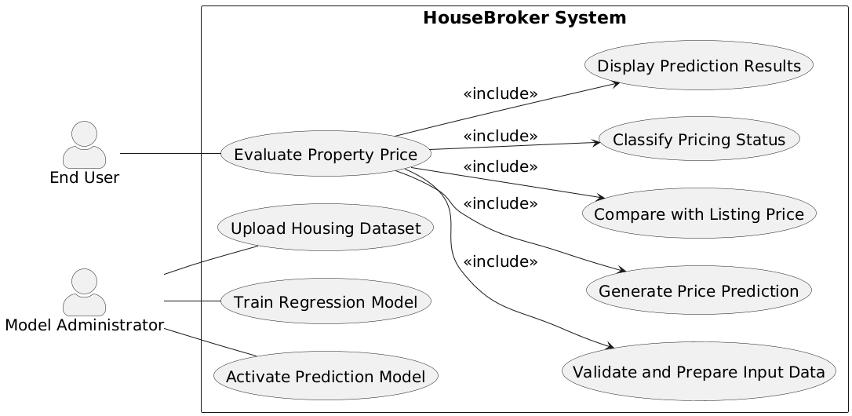
Figure 1. HouseBroker Use-Case Diagram
The diagram identifies two primary actors: the End User and the Model Administrator.
The End User interacts with the system to evaluate the estimated price of a property. The primary use case for this actor is Evaluate Property Price, which represents the complete analytical workflow. This use case includes several supporting processes. The system first validates and prepares input data to ensure that the provided housing attributes are complete and compatible with the trained model. It then generates a price prediction using the active regression model. If a listing price is available, the system compares it with the predicted value and determines whether the property is underpriced, fairly priced, or overpriced. The process concludes with the system displaying prediction results along with relevant insights.
The Model Administrator interacts with the system to manage datasets and predictive models. This actor is responsible for ensuring that the analytical foundation of the system remains accurate and up to date. The administrator can upload housing datasets, train regression models using prepared data, and activate a selected model for use in prediction tasks. These actions ensure that the system continues to produce reliable and relevant results.

Use-Case Descriptions
Use Case Name: Evaluate Property Price |  | ID: UC-1 | Importance Level: High
Associated Functional Requirements: 1–7, 14–25
Primary Actor: End User | Use Case Type: User Goal
Stakeholders and Interests:
End User – wants accurate and interpretable price estimation.
Model Administrator – ensures an active and validated regression model is available.
System – executes predictive logic and classification rules correctly.
Brief Description: This use case allows the End User to submit property attributes and obtain an estimated property price, price interval, and pricing classification. The system applies the active regression model and presents structured analytical results.

Trigger: The End User submits a completed property attribute profile.
Type: External
Relationships:
Association: End User
Include: Validate and Prepare Input Data
Generate Price Prediction
Classify Pricing Status
Display Prediction Results

Extend: Compare with Listing Price
Generalization: None
Normal Flow of Events:
- The End User enters required property attributes.
- The End User submits the property profile.
- The system validates and prepares input data.
- The system generates predicted property price.
- The system classifies pricing status.
- The system displays structured prediction results.
The use case ends when results are presented.
Sub-Flows: Compare with Listing Price
S-1:
  - The End User provides a listing price.
  - The system calculates deviation between predicted and listing price.
  - The system adjusts pricing classification based on deviation threshold.
Alternate/Exceptional Flows:
E-1: Missing Required Attribute
- The system detects incomplete property profile.
- The system displays a message identifying missing fields.
- The End User corrects and resubmits input.
E-2: No Active Prediction Model
- The system detects absence of activated regression model.
- The system displays notification indicating model unavailable.
- The use case terminates.
E-3: Invalid Attribute Format
- The system detects incompatible input values.
- The system prompts the End User to correct input format.
- The use case resumes at Step 3 of the normal flow.

Use Case Name: Validate and Prepare Input Data |  | ID: UC-2 | Importance Level: High
Associated Functional Requirements: 8–13
Primary Actor: System | Use Case Type: Included
Stakeholders and Interests:
End User – expects accurate and reliable prediction results based on valid input data.
Model Administrator – expects input structure to remain consistent with trained model configuration.
System – must ensure input compatibility before executing predictive computation.

Brief Description: This use case validates submitted property attributes and prepares them for regression-based prediction. The system verifies completeness, converts categorical variables, aligns feature structure, and applies scaling or standardization as required by the active model.

Trigger: This use case is triggered when the End User submits a property profile for evaluation.
Type: Internal
Relationships:
Association: None(System-driven)
Include: None
Extend: None
Generalization: None
Normal Flow of Events:
- The system verifies completeness of required property attributes.
- The system validates numeric range and data type of submitted values.
- The system converts categorical variables into numerical representations when necessary.
- The system aligns input attributes with the trained model’s feature structure.
- The system applies scaling or standardization consistent with model configuration.
- The system confirms that prepared data is ready for prediction.
The use case ends when input data is successfully validated and prepared.
Sub-Flows:
S-1: Feature Alignment Process
- The system compares submitted attributes with model feature schema.
- The system inserts default values for optional missing features when permitted.
The system rejects incompatible attribute structures if alignment fails.
Alternate/Exceptional Flows:
E-1: Missing Required Attribute
- The system detects incomplete property profile.
- The system flags missing fields.
- The system halts further processing.
E-2: Invalid Attribute Format
- The system detects non-numeric or incompatible input values.
- The system generates validation error message.
- The use case terminates until corrected input is provided.

Use Case Name: Generate Price Prediction |  | ID: UC-3 | Importance Level: High
Associated Functional Requirements: 14–16
Primary Actor: System | Use Case Type: Included
Stakeholders and Interests:
End User – expects an accurate and interpretable property price estimate.
Model Administrator – expects the activated regression model to be executed correctly.
System – must apply the active model consistently with its training configuration.
Brief Description:
This use case executes the activated regression model using validated and prepared input data. The system computes the predicted property price and derives a price interval based on model residual distribution.
Trigger: This use case is triggered after successful completion of input validation and preparation.
Type: Internal
Relationships:
Association: None(System-driven)
Include: None
Extend: None
Generalization: None
Normal Flow of Events:
            - The system retrieves the active regression model.
            - The system loads model parameters and configuration settings.
            - The system executes the regression model using prepared input features.
            - The system computes the predicted property price.
            - The system calculates a recommended price interval based on residual distribution or confidence estimation.
            - The system stores computed prediction values for subsequent classification and display.
The use case ends when predicted price and interval values are generated.
Sub-Flows:
S-1: Model Configuration Retrieval.
            - The system verifies that a trained model is activated.
The system loads feature weights or coefficients required for prediction.
Alternate/Exceptional Flows:
E-1: No Active Model Available
- The system detects absence of an activated regression model.
- The system generates a model unavailable notification.
- The use case terminates.
E-2: Model Execution Failure
- The system detects computational error during prediction execution.
- The system logs the error.
The system halts prediction process.

Use Case Name: Classify Pricing Status |  | ID: UC-4 | Importance Level: High
Primary Actor: System | Use Case Type: Included
Associated Functional Requirements: 17, 18, 19
Stakeholders and Interests:
End User – expects a clear classification indicating whether the property appears underpriced, fairly priced, or overpriced.
Model Administrator – expects classification thresholds to align with model logic and deviation rules.
System – must apply classification rules consistently and transparently.
Brief Description:
This use case assigns a pricing status classification based on the predicted property price and, when available, comparison with a listing price. The system determines whether the property falls within acceptable deviation thresholds or exceeds defined bounds.

Trigger: This use case is triggered after predicted price and price interval values are generated.
Type: Internal
Relationships:
Association: None (System-Driven)
Include: None
Extend: None
Generalization: None
Normal Flow of Events:
- The system retrieves predicted property price.
- The system retrieves recommended price interval.
- The system evaluates deviation thresholds defined in classification rules.
- The system determines pricing category based on deviation logic.
- The system assigns classification as underpriced, fairly priced, or overpriced.
- The system stores classification result for presentation.
The use case ends when pricing classification is assigned.
SubFlows:
S-1: Threshold Evaluation Logic
- The system compares predicted value against acceptable deviation bounds.
- The system checks interval consistency to ensure logical classification.
- The system finalizes classification label.
Alternate/Exceptional Flows:
E-1: Missing Prediction Value
- The system detects absence of predicted price.
- The system halts classification process.
- The use case terminates.
E-2: Invalid Threshold Configuration
- The system detects misconfigured deviation thresholds.
- The system logs configuration error.
- The system assigns neutral classification and terminates classification process.

Use Case Name: Compare with Listing Price |  | ID: UC-5 | Importance Level: Medium
Primary Actor: End User | Use Case Type: Extension
Associated Functional Requirements: 6, 17, 18, 19
Stakeholders and Interests:
End User – wants to know whether the listed property price deviates from the predicted value.
Model Administrator – expects deviation logic to be applied consistently.
System – must calculate deviation and adjust classification accurately.
Brief Description:
This use case compares the predicted property price with a listing price optionally provided by the End User. The system calculates percentage deviation and adjusts pricing classification when deviation exceeds defined thresholds.
Trigger: The End User provides a listing price during or after property attribute submission.
Type: External
Relationships:
Association: End User
Include: None
Extend: Evaluate Property Value
Generalization: None
Normal Flow of Events:
- The End User enters listing price.
- The system retrieves predicted property price.
- The system calculates absolute and percentage deviation between predicted and listing price.
- The system evaluates deviation against defined classification thresholds.
- The system adjusts pricing classification if deviation exceeds acceptable bounds.
- The system stores updated classification result.
The use case ends when comparison results are incorporated into final classification.
SubFlows:
S-1: Deviation Calculation Logic
- The system computes difference between listing and predicted price.
- The system converts difference into percentage deviation.
- The system evaluates whether deviation falls within acceptable range.
Alternate/Exceptional Flows:
E-1: Listing Price Not Provided
- The system detects absence of listing price.
- The system skips comparison logic.
- The use case terminates without modification to classification.
E-2: Invalid Listing Price Format
- The system detects non-numeric listing price input.
- The system prompts End User to correct input.
- The use case resumes at Step 1 of the normal flow.

Use Case Name: Display Prediction Result |  | ID: UC-6 | Importance Level: High
Primary Actor: End User | Use Case Type: Included
Associated Functional Requirements: 22-25
Stakeholders and Interests:
End User – expects clear, structured, and interpretable prediction results.
Model Administrator – expects influential variables and computed metrics to be presented accurately.
System – must ensure analytical outputs are displayed consistently and without distortion.

Brief Description:
This use case presents the predicted property price, recommended price interval, pricing classification, and influential variables to the End User in a structured format. The output must remain transparent and interpretable.
Trigger: This use case is triggered after price prediction and classification have been completed.
Type: Internal
Relationships:
Association: End User
Include: None
Extend: None
Generalization: None
Normal Flow of Events:
- The system retrieves predicted property price.
- The system retrieves recommended price interval.
- The system retrieves pricing classification result.
- The system retrieves influential variable metrics.
- The system formats results for presentation.
- The system displays structured prediction output to the End User.
The use case ends when results are presented.
SubFlows:
S-1: Result Formatting Process
- The system applies standardized numerical formatting.
- The system organizes output fields into structured layout.
- The system verifies completeness of displayed components.
Alternate/Exceptional Flows:
E-1: Missing Prediction Components
- The system detects absence of one or more required output values.
- The system logs display error.
- The system presents available results with notification.
E-2: Output Rendering Failure
- The system detects presentation error.
- The system logs rendering failure.
- The use case terminates.

Use Case Name: Upload Housing Dataset |  | ID: UC-7 | Importance Level: High
Primary Actor: Model Administrator | Use Case Type: Administrative
Associated Functional Requirements: 26, 27
Stakeholders and Interests:
Model Administrator – wants to import valid housing datasets for model training and evaluation.
End User – expects predictions to be based on reliable and updated datasets.
System – must ensure dataset integrity before enabling analytical use.
Brief Description:
This use case allows the Model Administrator to upload housing datasets into the system. The system validates dataset structure, verifies required attributes, and stores approved datasets for further processing and model training.
Trigger: The Model Administrator initiates dataset upload operation.
Type: External
Relationships:
Association: Model Administrator
Include: None
Extend: None
Generalization: None
Normal Flow of Events:
- The Model Administrator selects a housing dataset file.
- The Model Administrator uploads the dataset into the system.
- The system verifies file format compatibility.
- The system validates dataset structure and required attributes.
- The system checks for missing or inconsistent values.
- The system confirms successful validation.
- The system stores dataset for training and analytical use.
The use case ends when the dataset is successfully uploaded and stored.
SubFlows:
S-1: Dataset Validation Process
- The system verifies presence of required feature columns.
- The system identifies duplicate or inconsistent records.
- The system flags structural issues for correction.
Alternate/Exceptional Flows:
E-1: Invalid File Format
- The system detects unsupported dataset format.
- The system displays format error message.
- The Model Administrator corrects and re-uploads dataset.
E-2: Missing Required Attributes
- The system detects absence of mandatory feature columns.
- The system displays validation report.
- The use case terminates until corrected dataset is provided.

Use Case Name: Train Regression Model |  | ID: UC-8 | Importance Level: High
Primary Actor: Model Administrator | Use Case Type: Administrative
Associated Functional Requirements: 28-30
Stakeholders and Interests:
Model Administrator – wants to train a statistically valid and interpretable regression model.
End User – expects predictions to be based on properly trained models.
System – must execute training logic consistently and compute reliable evaluation metrics.
Brief Description:
This use case allows the Model Administrator to train a regression-based prediction model using uploaded housing datasets. The system prepares the dataset, performs feature selection, executes regression training, and computes evaluation metrics such as RMSE and R².
Trigger: The Model Administrator initiates model training using a selected dataset.
Type: External
Relationships:
Association: Model Administrator
Include: None
Extend: None
Generalization: None
Normal Flow of Events:
- The Model Administrator selects a validated dataset for training.
- The system performs dataset cleaning by handling missing or inconsistent values.
- The system performs feature selection based on statistical relevance.
- The system splits dataset into training and validation subsets.
- The system executes regression training using prepared features.
- The system computes model coefficients or learned parameters.
- The system evaluates model performance using RMSE and R² metrics.
- The system stores trained model and associated evaluation metrics.
The use case ends when the trained model and metrics are saved.
SubFlows:
S-1: Feature Selection Process
- The system evaluates statistical relevance of candidate features.
- The system removes redundant or insignificant variables.
- The system finalizes selected feature set for model training.
Alternate/Exceptional Flows:
E-1: Insufficient Dataset Size
- The system detects insufficient data for reliable model training.
- The system displays warning message.
- The training process terminates.
E-2: Training Failure
- The system detects computational or convergence error during regression execution.
- The system logs training error.
- The use case terminates without storing model.

Use Case Name: Activate Prediction Model |  | ID: UC-9 | Importance Level: High
Primary Actor: Model Administrator | Use Case Type: Administrative
Associated Functional Requirements: 31-34
Stakeholders and Interests:
Model Administrator – wants to designate a validated regression model for active prediction use.
End User – expects predictions to be generated using the most appropriate and evaluated model.
System – must ensure that only one approved model is active for prediction tasks.
Brief Description:
This use case allows the Model Administrator to select and activate a trained regression model for prediction operations. The system verifies model availability, confirms evaluation metrics, and sets the selected model as the active prediction engine.
Trigger: The Model Administrator selects a trained model for activation.
Type: External
Relationships:
Association: Model Administrator
Include: None
Extend: None
Generalization: None
Normal Flow of Events:
- The Model Administrator views available trained models.
- The system displays stored evaluation metrics for each model.
- The Model Administrator selects a model for activation.
- The system verifies that the selected model has valid evaluation metrics.
- The system deactivates any previously active model.
- The system marks the selected model as active.
- The system confirms successful activation.
The use case ends when the selected model becomes the active prediction model.
SubFlows:
S-1: Model Verification Process
- The system checks existence of trained model parameters.
- The system verifies presence of evaluation metrics.
- The system confirms model readiness for prediction tasks.
Alternate/Exceptional Flows:
E-1: No Trained Models Available
- The system detects absence of trained models.
- The system displays notification indicating that model training is required.
- The use case terminates.
E-2: Invalid Model Selection
- The system detects incomplete or corrupted model configuration.
- The system prevents activation.
- The system logs configuration error.

Activity diagram
The activity diagram illustrates the workflow involved when a property is evaluated in the HouseBroker system. It represents the sequence of actions performed by the End User and the system, along with decision points and data processing steps. Activity diagrams are useful for modeling business processes and system workflows, as they show how tasks progress from initiation to completion (Dennis et al., 2020).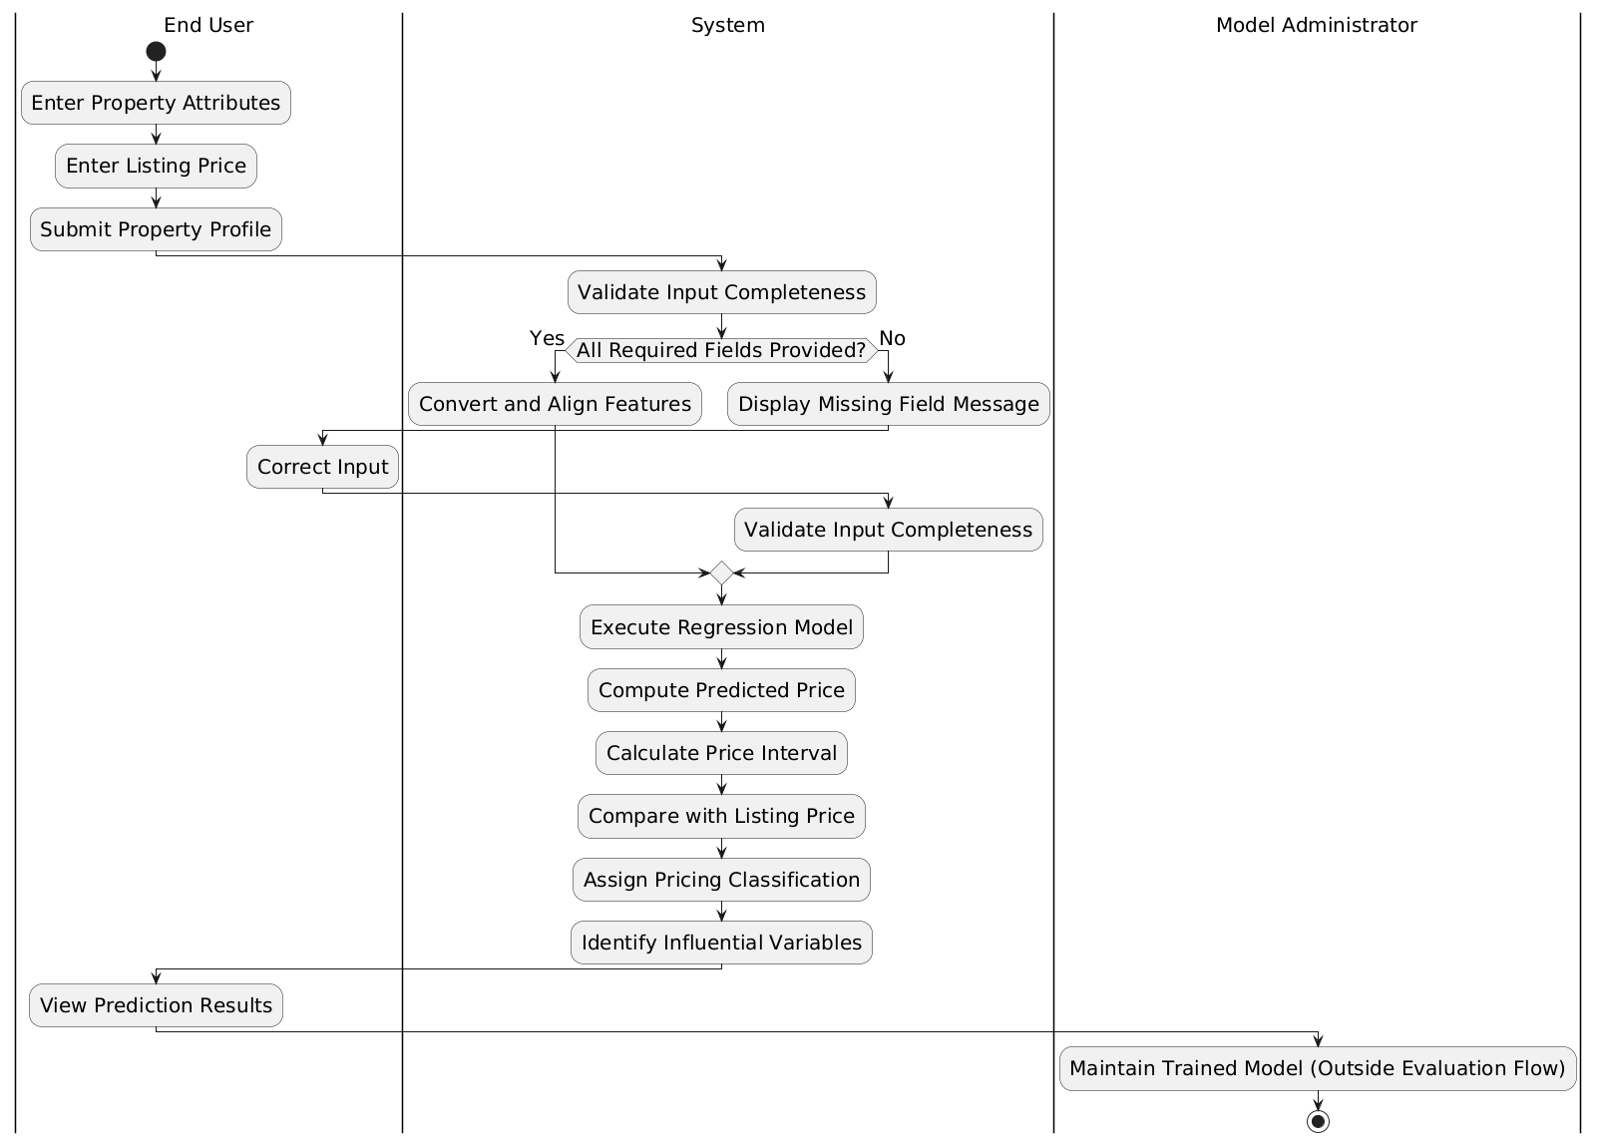
Figure 2. Property Price Evaluation Activity Diagram
The process begins when the End User enters property attributes and optionally provides a listing price, then submits the property profile for analysis. The system first validates whether all required inputs are present. If required fields are missing, the system displays a message prompting the user to correct the input before proceeding. This validation step ensures that the prediction process operates on complete and consistent data.
Once the inputs are validated, the system prepares the data by converting and aligning the features to match the structure expected by the trained regression model. The model is then executed to compute the predicted property price. Following prediction, the system calculates a price interval to represent expected variation. If a listing price is available, the system compares it with the predicted value and assigns a pricing classification indicating whether the property is underpriced, fairly priced, or overpriced.
The system then identifies the most influential variables contributing to the prediction and presents the results to the user in a structured format. The diagram also indicates that model maintenance activities, such as updating datasets and training models, are performed by the Model Administrator outside the main evaluation workflow but are essential for maintaining prediction accuracy and system reliability.

Behavioral Model
The behavioral model describes how the HouseBroker system operates over time by capturing the interactions between system components during execution. While structural models define system components and their relationships, behavioral models focus on how these components collaborate to perform specific tasks. This perspective is essential for validating system logic, ensuring that data flows correctly across components, and confirming that the sequence of operations supports the intended functionality (Dennis et al., 2020). In this project, the behavioral model is represented using a sequence diagram for the core use case, Evaluate Property Price.

Sequence diagram
The sequence diagram illustrates how the HouseBroker system performs the Evaluate Property Price use case through interactions between system objects. It provides a detailed view of message flow, execution order, and responsibility distribution across components involved in the prediction process.
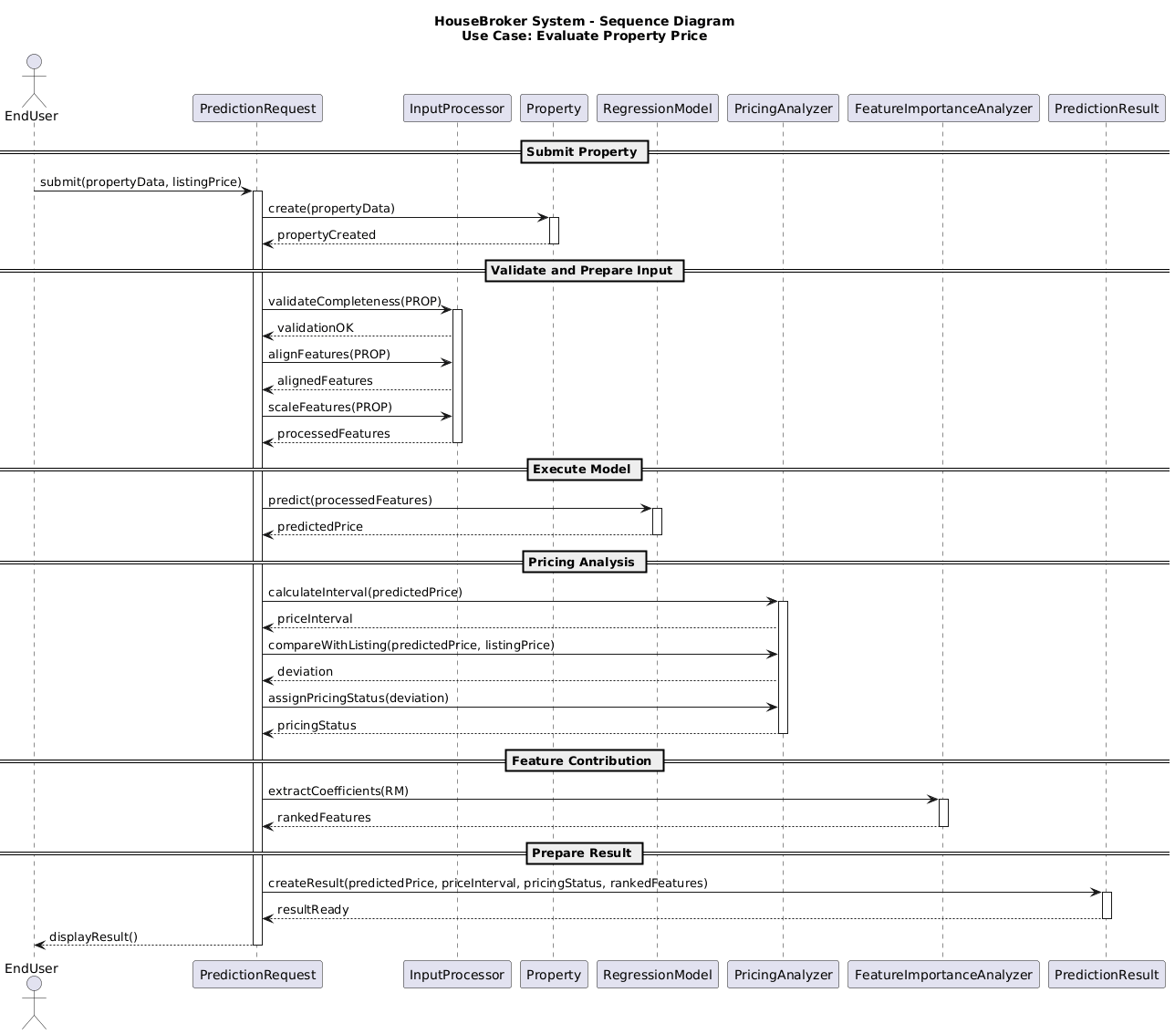
Figure 3. Sequence Diagram for Evaluate Property Price Use Case
The sequence begins when the End User submits property data along with an optional listing price. This request is handled by the PredictionRequest component, which acts as the interface between the user and the system. The system then creates a Property object to encapsulate all input attributes in a structured form.
The InputProcessor receives the Property object and performs input validation and preparation. It verifies that all required attributes are present and ensures that the data conforms to expected formats. Once validated, the processor aligns the input features with the structure used during model training. This includes transforming categorical values into numerical representations and applying scaling where required. The result is a set of processed features ready for prediction.
The processed input is passed to the RegressionModel, which executes the prediction. Using the trained model, it computes the estimated property price based on the provided features. This step represents the core analytical computation within the system.
After obtaining the predicted value, the PricingAnalyzer performs further evaluation. It calculates a price interval to account for expected variation in predictions. If a listing price is available, the analyzer compares it with the predicted value and computes the deviation. Based on this comparison, the system assigns a pricing classification indicating whether the property is underpriced, fairly priced, or overpriced. This stage converts the numerical prediction into a meaningful decision-support output.
Next, the FeatureImportanceAnalyzer identifies the variables that have the greatest influence on the prediction. By examining model coefficients or contribution metrics, it ranks the input features according to their impact. This step enhances interpretability by explaining how different property attributes contributed to the final estimate.
Finally, the system creates a PredictionResult object that consolidates all outputs, including the predicted price, calculated price interval, pricing classification, and ranked feature contributions. This object is returned to the End User, and the results are displayed in a structured and interpretable format.
The sequence diagram demonstrates how system components interact in a coordinated and ordered manner to transform user input into actionable insights. Each component performs a clearly defined role, ensuring modularity, traceability, and alignment with the system’s functional requirements.

Design Model (Class and Method Design)
The design model translates the analysis models into a concrete system structure by defining how classes, methods, and modules are organized to implement the required functionality. It focuses on the internal organization of the system, including how responsibilities are distributed across components and how different parts of the system interact. A well-defined design model improves maintainability, scalability, and traceability between requirements and implementation (Dennis et al., 2020).
In HouseBroker, the design follows an object-oriented approach where each major responsibility—input processing, prediction, analysis, and result generation—is encapsulated within dedicated classes. To further organize these components, the system is structured into logical groupings using packages. This modular organization ensures that related classes are grouped together, reducing complexity and supporting clear separation of concerns.

Package Diagram
The package diagram represents the high-level organization of the HouseBroker system by grouping related classes into cohesive modules. It provides a structural overview of how the system is partitioned into functional areas and how these areas depend on each other.
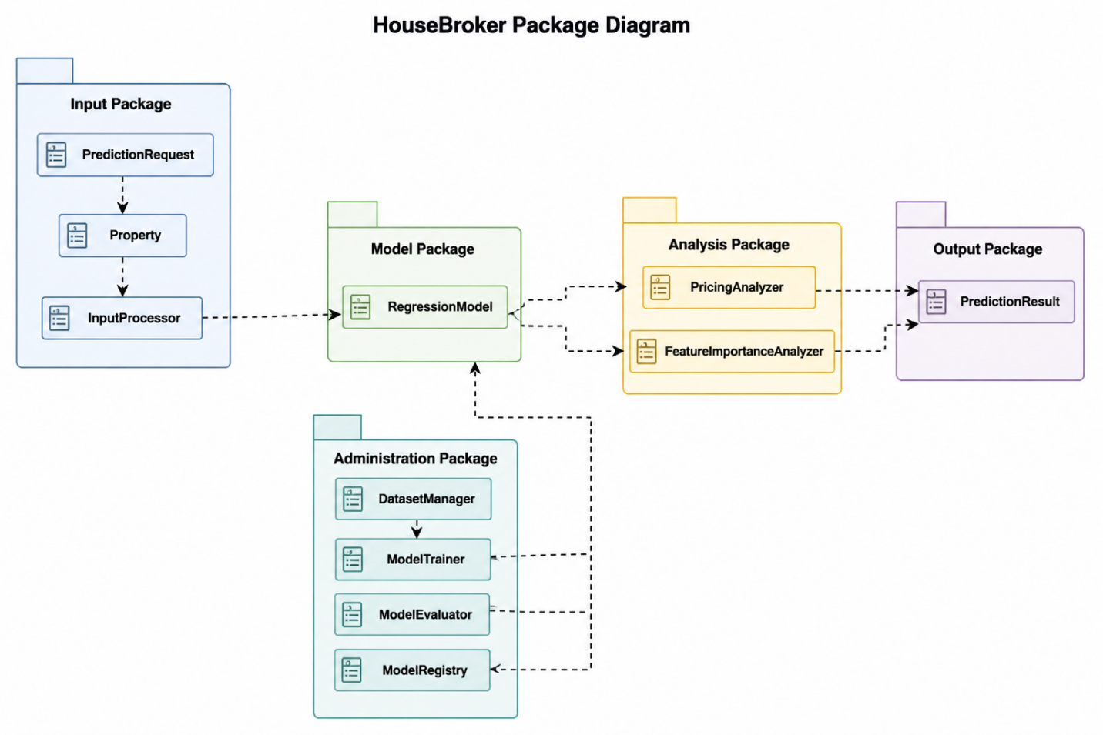
Figure 4. HouseBroker Package Diagram
The system is organized into several key packages, each responsible for a specific aspect of the overall functionality.
The Input Package contains classes responsible for handling user input and preparing data for processing. This includes components such as PredictionRequest, Property, and InputProcessor. These classes manage data collection, validation, and transformation, ensuring that user input is structured and compatible with the predictive model.
The Model Package encapsulates the predictive modeling logic. It includes the RegressionModel class, which is responsible for executing the trained regression algorithm. This package isolates the core prediction functionality, allowing models to be updated or replaced without affecting other parts of the system.
The Analysis Package contains components that interpret prediction results. Classes such as PricingAnalyzer and FeatureImportanceAnalyzer evaluate the predicted price, compute price intervals, classify pricing status, and identify influential variables. This separation ensures that analytical interpretation is handled independently from raw prediction.
The Output Package is responsible for preparing and presenting results to the user. The PredictionResult class aggregates all outputs, including predicted price, price range, classification, and feature contributions. This package ensures that results are structured and ready for display.
The Administration Package supports model and dataset management. It includes functionalities for dataset handling, model training, evaluation, and activation. This package is primarily used by the Model Administrator and operates independently of the main prediction workflow.
Dependencies between packages follow a logical flow. The Input Package provides processed data to the Model Package. The Model Package produces predictions that are passed to the Analysis Package. The Analysis Package generates interpreted results, which are then formatted by the Output Package. The Administration Package supports the Model Package by maintaining datasets and trained models.
This package-level organization ensures that the system remains modular and extensible. Changes within one package, such as updating the regression model or modifying analysis logic, can be made with minimal impact on other components. The design reflects a clear separation between data handling, computation, analysis, and presentation, which aligns with object-oriented design principles and supports maintainable system development (Dennis et al., 2020).

Design Model —Contract
Operation: evaluatePropertyPrice(propertyData, listingPrice)
This operation processes user-provided property details and an optional listing price to generate a pricing evaluation. The system validates and prepares the input data, executes the regression model, calculates a predicted price and price interval, determines pricing classification, and returns structured results.
Inputs: propertyData — property attributes such as rooms, location, and accessibility, listingPrice — optional listed property price
Output: predicted price, price range, pricing classification, influential features
Preconditions: Trained regression model is available, Required preprocessing configuration exists, Valid property data is submitted.
Postconditions: Input data is validated and transformed, Property price prediction is generated
Price interval and classification are computed, Influential features are identified, Structured result is returned
Failure Condition: If required inputs are missing or invalid, the system returns a validation error and prediction is not generated.

Method Specification
Class: PredictionController
Method: evaluatePropertyPrice(propertyData, listingPrice)
This method coordinates the complete property evaluation workflow. It validates input data, preprocesses features, executes the regression model, computes pricing analysis, and prepares the final prediction result.
Parameters: propertyData — dictionary containing property attributes, listingPrice — optional listing price
Returns: PredictionResult containing predicted price, price range, classification, and feature importance.
Processing Steps: Create property object from input data, Validate and preprocess features, Execute regression model prediction, Compute price interval, Compare predicted and listing prices, Determine pricing classification, Extract influential features, Return structured prediction result.
Error Handling: Invalid or missing inputs return validation errors, Model execution failures return system error messages.
Design Considerations:
The method centralizes workflow control while delegating preprocessing, prediction, classification, and feature analysis to separate components to maintain modularity.

Structural Model
The structural model defines the static organization of the HouseBroker system by identifying system components, their attributes, and the relationships between them. Unlike behavioral models, which focus on system execution over time, structural models describe how the system is built and how responsibilities are distributed across classes and objects. This model ensures that the system design supports the required functionality and maintains clear separation of concerns (Dennis et al., 2020).

Class Diagram
The class diagram represents the to-be system design by defining the key classes, their attributes, methods, and relationships. The structure is centered around the processing of a prediction request and the generation of interpretable pricing results.
The process begins with the EndUser, who initiates the workflow by creating a PredictionRequest. This class acts as the coordination point for the prediction process, managing submission and validation tracking. The request contains property-related data encapsulated in the Property class, which stores attributes such as location, number of rooms, accessibility score, and listing price.
The InputProcessor is responsible for preparing the input data. It validates completeness, checks value ranges, converts categorical variables, and aligns features with the model structure. This ensures that the input is consistent with the data used during model training.
The RegressionModel represents the core predictive component of the system. It defines general methods such as training, evaluation, and prediction. Specialized implementations such as LinearRegressionModel and RidgeRegressionModel extend this class, allowing flexibility in model selection while maintaining a consistent interface.

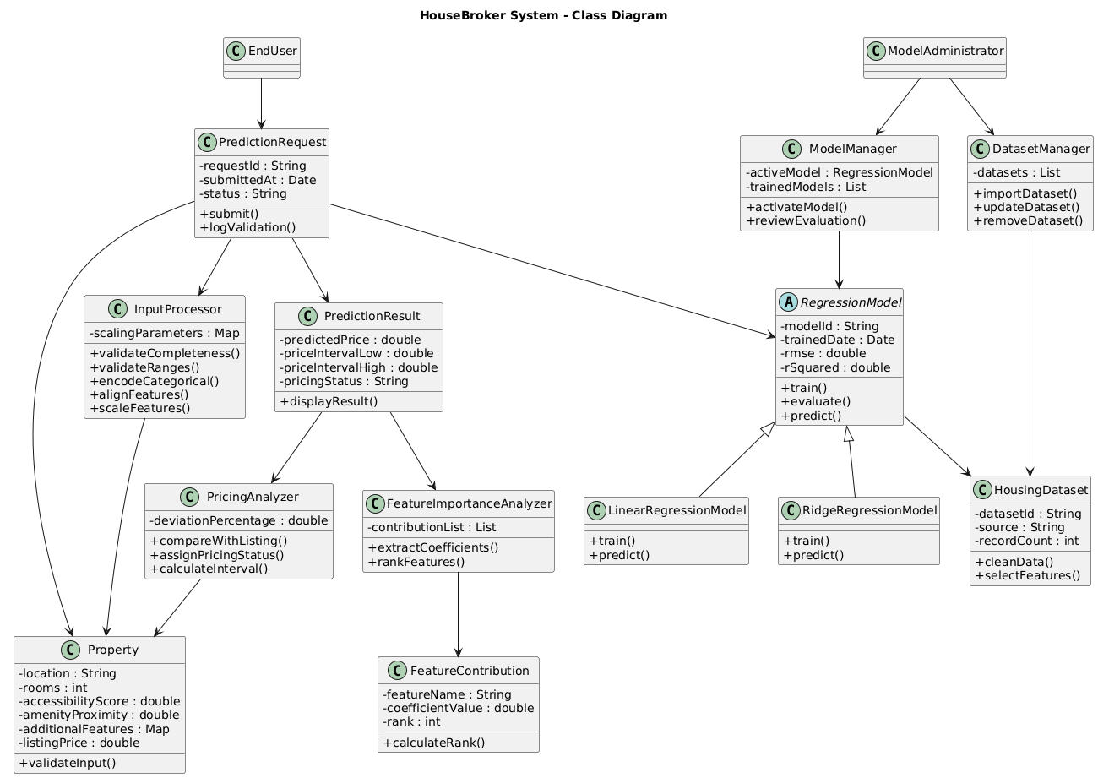
Figure 4. HouseBroker Class Diagram
Once a prediction is generated, the PricingAnalyzer evaluates the predicted value by comparing it with the listing price and assigning a pricing classification. It also calculates the price interval and deviation percentage. The FeatureImportanceAnalyzer complements this process by identifying and ranking the most influential features, with each contribution represented by the FeatureContribution class.
The results of the analysis are encapsulated in the PredictionResult class, which stores the predicted price, price range, pricing status, and feature contributions. This class is responsible for presenting the final output to the user.
Administrative functionality is handled by the ModelAdministrator, who interacts with the ModelManager and DatasetManager classes. These components manage datasets, train models, evaluate performance, and activate models for prediction. The HousingDataset class represents the data used for training and evaluation.
Together, these classes define a modular and extensible system structure, where each component has a clearly defined responsibility aligned with the system’s functional requirements.

Object Diagram
The object diagram provides a runtime snapshot of the HouseBroker system during the execution of a property price evaluation. While the class diagram defines the general structure, the object diagram shows how specific instances interact in a real scenario.
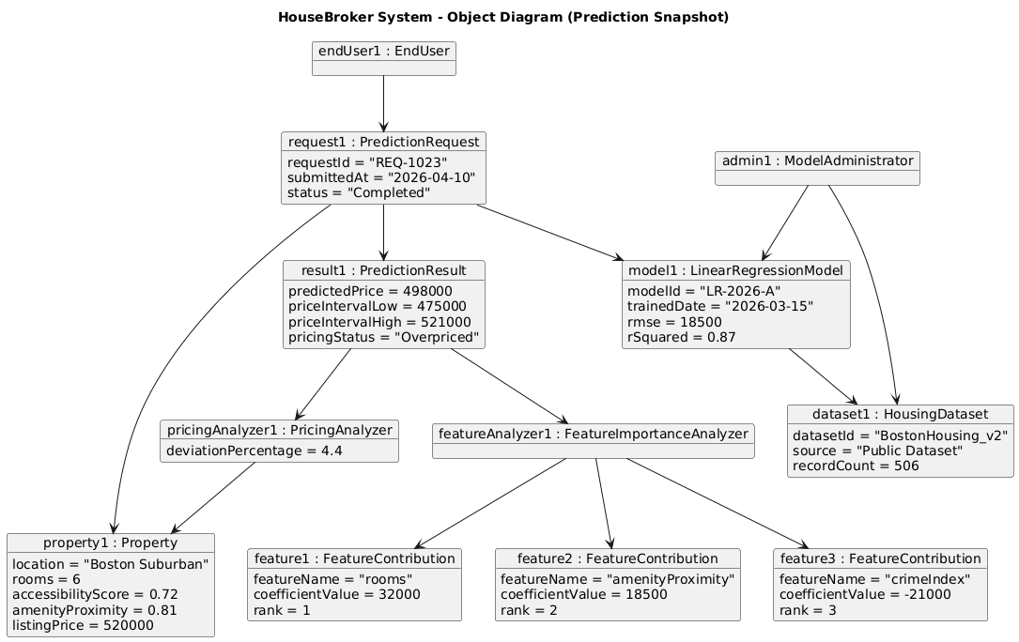
Figure 5. Object Diagram – Prediction Snapshot
In this snapshot, an instance of EndUser initiates the process by submitting a PredictionRequest with a unique request identifier and submission timestamp. This request contains a Property instance with specific attribute values such as location, number of rooms, accessibility score, and listing price.
The system processes this input using a trained LinearRegressionModel, which has associated attributes such as model identifier, training date, RMSE, and R² score. The model is linked to a HousingDataset, representing the dataset used during training.
The prediction process produces a PredictionResult instance containing the estimated price, calculated price interval, and pricing classification. Supporting objects such as PricingAnalyzer compute deviation and classification, while FeatureImportanceAnalyzer identifies key contributing variables.
Each influential variable is represented as a FeatureContribution object, showing the feature name, coefficient value, and ranking. These objects collectively explain how the final prediction was derived.
The diagram also includes an instance of ModelAdministrator, which maintains the trained model and dataset outside the immediate prediction flow. This highlights the separation between operational prediction and administrative management.
This object-level view demonstrates how the system’s structural components are instantiated and interact during execution, providing a concrete representation of the prediction workflow.

Data Management Layer Designs
This section describes how data is managed in the actual implementation of the HouseBroker system. While conceptual designs often assume a relational database, this project is implemented as a standalone analytical system in a Jupyter/Python environment, where persistence is handled using files and in-memory objects. Therefore, the data management layer reflects a file-based and object-based persistence approach, aligned with how the system was actually built and executed.

Object Persistence Format
The system persists data using a combination of structured files and serialized objects, depending on the type of data being stored.
The PredictionRequest and Property data are not stored in a database. Instead, they are handled as in-memory Python objects (dictionaries and class instances) during execution. These objects are created at runtime when the user provides input and are passed through the processing pipeline without long-term storage.
The PredictionResult is also generated dynamically and exists as an object during execution. It contains fields such as predictedPrice, priceIntervalLow, priceIntervalHigh, pricingStatus, and rankedFeatures. In the current implementation, results are displayed directly to the user and are not persisted unless explicitly exported. If persistence is required, the result can be stored in a JSON format, which preserves structure and supports easy readability.
The RegressionModel is persisted using binary serialization (Pickle/Joblib). This allows the trained model, including learned parameters and coefficients, to be saved and reused without retraining. Model metadata such as RMSE and R² are stored alongside the model or printed during evaluation.
The HousingDataset is stored as a CSV file, which serves as the primary data source for training and evaluation. Data preprocessing steps such as cleaning and feature selection are performed in memory using Pandas, and the processed dataset is not separately persisted unless explicitly saved.
This approach reflects a lightweight persistence strategy suitable for a demonstration system, where the focus is on analytical workflow rather than full-scale data storage infrastructure.

Database Schema
The HouseBroker system does not implement a traditional relational database schema. Instead, it relies on a file-based data management approach combined with in-memory structures, which is consistent with its implementation in a notebook-based environment.
From an implementation standpoint, the system’s data organization can be described as follows:
Datasets
- Stored as CSV files (e.g., Boston Housing dataset). These files act as the primary data source and are loaded into Pandas DataFrames for processing.
Model Storage
- Trained models are stored as serialized binary files using Pickle or Joblib. Each model file represents a trained RegressionModel instance and can be loaded when needed.
Input Data
- User input is captured as Python dictionaries and converted into Property objects. This data is transient and exists only during execution.
Prediction Output
- Results are generated as PredictionResult objects and displayed directly. No persistent storage layer is implemented for storing historical predictions.
Feature Contributions
- Derived dynamically from model coefficients and stored temporarily as lists of FeatureContribution objects.
This design reflects a pipeline-based architecture rather than a database-driven system. Data flows through stages—input → preprocessing → prediction → analysis → output—without being committed to a persistent relational structure.
From a system design perspective, this approach is appropriate for a prototype or academic implementation, where the focus is on demonstrating predictive modeling, data processing, and interpretability rather than building a production-grade data storage system. It also aligns with typical machine learning workflows, where datasets and models are managed as files and processed in memory (Géron, 2022).

Human–Computer Interaction Layer Design
This section describes how users interact with the HouseBroker system through a simple and interpretable interface. The goal of the interaction layer is to support the user in entering property details, initiating analysis, and understanding the results without requiring technical knowledge of the underlying model. The design prioritizes clarity, minimal input effort, and direct visibility of outputs, which is consistent with decision-support systems that present analytical results to non-technical users (Dennis et al., 2020).

Wireframe Design
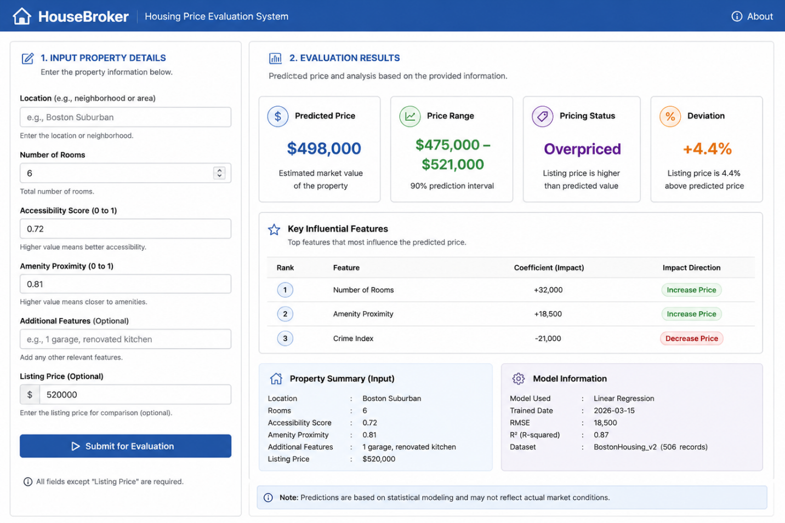
Figure 6. HouseBroker Wireframe — Input and Results Interface
The interface is divided into two main sections: Input Panel and Results Panel.
Given that the system is implemented as a prototype in a notebook-based environment, the interface is conceptualized as a web-style form and results panel, representing how the system would function in a practical deployment. The wireframe focuses on layout, input flow, and output presentation rather than visual styling.
The wireframe for the HouseBroker system represents a simple and structured user interface designed to support property price evaluation in a clear and interpretable manner. The layout follows a two-panel structure, with the input section positioned on the left and the results section displayed on the right. This arrangement reflects the actual workflow of the system, where user input is provided first and the corresponding analytical output is presented immediately after processing.
The input panel is designed as a vertically organized form that guides the user through entering property details. It includes fields for location, number of rooms, accessibility score, and proximity to amenities, along with an optional field for listing price. Additional features can also be provided as optional input. Each field is labeled clearly, and placeholder text is used to indicate expected input values. A submission button is placed at the end of the form to initiate the evaluation process. The layout ensures that all required inputs are visible in a single view, reducing user effort and minimizing navigation complexity.
The results panel presents the output generated by the system in a structured and visually separated format. Key outputs such as the predicted property price, price range, and pricing status are displayed prominently to support quick interpretation. If a listing price is provided, the system also displays the deviation between the predicted and listed values. Below these primary results, a section highlights the most influential features contributing to the prediction, including their relative impact and ranking. Additional sections provide a summary of the input data and information about the model used, such as model type and evaluation metrics.
The interface design emphasizes clarity and interpretability. Important outputs are highlighted, while supporting details are organized in a way that does not overwhelm the user. The interaction flow is linear and intuitive: the user enters property details, submits the form, and receives immediate feedback in the results panel. This design aligns with the system’s objective of providing transparent and accessible analytical insights without requiring technical expertise.

Physical Architecture Layer Design
This section defines the physical environment in which the HouseBroker system is developed and executed. It specifies the hardware and software configuration, along with operational and performance requirements. Since the system is implemented as a standalone analytical application in a Python/Jupyter environment, the physical architecture reflects a single-machine execution model rather than a distributed or cloud-based deployment. The design prioritizes simplicity, reproducibility, and sufficient computational capability to support regression modeling workflows (Dennis et al., 2020; Géron, 2022).

Hardware and Software Specification
The HouseBroker system is designed to run on a standard personal computing environment suitable for data analysis tasks.
From a hardware perspective, the system requires a machine with a multi-core processor, such as an Intel i5 or equivalent, with at least 8 GB of RAM to support in-memory data processing using Pandas and model execution using Scikit-learn. Storage requirements are modest, as datasets such as the Boston Housing dataset are relatively small; therefore, 10–20 GB of available disk space is sufficient for datasets, serialized models, and development artifacts. No GPU acceleration is required, as the system uses traditional regression models rather than deep learning techniques.
From a software perspective, the system is implemented using Python in a Jupyter Notebook or similar development environment. Key libraries include Pandas for data handling, NumPy for numerical computation, and Scikit-learn for regression modeling. Joblib or Pickle is used for model serialization. The system can be executed on common operating systems such as Windows, macOS, or Linux without modification. A web interface is conceptually designed but not deployed; therefore, no web server or frontend framework is required in the current implementation.

Operational Requirements
The system is intended for interactive use in a development or demonstration environment. Users access the system through a notebook interface or a simple front-end form, where they input property attributes and initiate evaluation.
The system requires that a trained regression model be available before prediction can occur. Model training is performed separately by the Model Administrator using available datasets. Once trained, the model is loaded into memory and used for prediction tasks. Dataset files must be accessible in the local file system, and appropriate preprocessing steps must be applied before training.
Administrative operations such as dataset loading, model training, and evaluation are performed manually within the execution environment. The system does not require continuous operation and can be executed on demand. No external system dependencies or network connectivity are required beyond initial dataset access.

Performance Requirements
The performance requirements are defined based on the expected workload and system usage in a standalone analytical setting.
The system must process a single prediction request within less than 1 second, including input validation, feature preparation, model execution, and result generation.
The system must complete regression model training on a dataset of up to 1,000 records within 5–10 seconds, depending on feature complexity.
Input validation and preprocessing must be completed within 100–200 milliseconds to maintain responsiveness.
Memory usage during execution should remain within 500 MB to 1 GB, ensuring compatibility with standard personal computing environments.
The system should support handling datasets with up to 10,000 records without significant degradation in performance, although typical usage involves smaller datasets.
These performance targets are realistic for a regression-based system implemented using Scikit-learn and executed on a standard CPU. They ensure that the system remains responsive for interactive use while maintaining accurate and interpretable predictions.

Construction
This section describes the unit testing approach used to validate individual components of the HouseBroker system. Unit testing focuses on verifying that each class and method performs its intended function correctly in isolation. Given the modular, object-oriented design of the system, unit tests were applied to core components such as input processing, model prediction, pricing analysis, and feature importance extraction. This ensures that each part of the analytical pipeline behaves as expected before integration (Dennis et al., 2020).

Unit Test Description
Unit testing in the HouseBroker system was conducted using controlled inputs and expected outputs to validate the behavior of key methods. Since the system is implemented in a Python notebook environment, tests were performed using direct function calls and assertion-based validation rather than a full automated testing framework.
The InputProcessor component was tested to ensure correct handling of input validation and preprocessing. Test cases included scenarios with complete input data, missing fields, and invalid numeric ranges. The expected outcome was that valid inputs are successfully processed into aligned feature vectors, while invalid inputs trigger appropriate validation responses.
The RegressionModel was tested using known input datasets to verify that predictions are generated correctly. Predefined input feature sets were passed to the model, and the output was compared against expected numerical ranges. This confirmed that the model produces consistent and reasonable predictions based on trained parameters.
The PricingAnalyzer was tested to validate price interval calculation and classification logic. Test inputs included combinations of predicted prices and listing prices to ensure correct classification into underpriced, fairly priced, or overpriced categories. Boundary conditions were also tested to confirm correct behavior near classification thresholds.
The FeatureImportanceAnalyzer was tested by providing model coefficients and verifying that features are correctly ranked based on contribution magnitude. The test ensured that higher absolute coefficient values correspond to higher-ranked features.
The PredictionController (evaluatePropertyPrice method) was tested as an integration-focused unit to ensure that all components work together correctly. A complete property input was provided, and the system was expected to return a structured PredictionResult containing all required fields, including predicted price, price interval, pricing status, and ranked features.
Error handling was also tested across components by introducing invalid or incomplete inputs. The system was expected to prevent execution of downstream processes and return clear validation messages.
These unit tests confirm that individual components behave correctly and support reliable system operation. The testing approach is consistent with the project’s scope, focusing on validating analytical logic and workflow correctness within a prototype environment (Géron, 2022).

Integration Testing
Integration testing verifies that multiple components of the HouseBroker system work together correctly as a unified pipeline. While unit tests validate individual functions in isolation, integration tests ensure that the end-to-end data flow—from input preprocessing to final output—is consistent, accurate, and reliable (Dennis et al., 2020).

Given the implementation is a function-based pipeline in a Jupyter environment, integration testing is performed by executing the full workflow with controlled inputs and validating combined outputs across multiple components.
Integration Test Description
The integration tests focus on validating interactions between the following components:
- Input preprocessing → prediction model
- Prediction → interval computation → classification
- Model output → feature importance extraction
- Full pipeline execution via housebroker_system()

Integration Test 1: End-to-End Pipeline Validation
This test verifies that all components work together correctly.

def integration_test_full_pipeline():
sample = X_test.iloc[[1]]
listing_price = y_test.iloc[1] * 1.05

result = housebroker_system(
sample,
model,
scaler,
feature_columns,
residuals,
listing_price
)

assert isinstance(result, dict)
assert "Predicted Price" in result
assert "Price Range" in result
assert "Classification" in result
assert "Top Features" in result

print("PASS: Full pipeline integration successful")

Integration Test 2: Data Flow Consistency
This test ensures that preprocessing → prediction → interval computation are properly connected.

def integration_test_data_flow():
sample = X_test.iloc[[2]]

processed = preprocess_input(sample, scaler, feature_columns)
pred = predict_price(model, processed)
lower, upper = compute_interval(pred, residuals)

assert processed.shape[1] == len(feature_columns)
assert lower < pred < upper

print("PASS: Data flow across components is consistent")

Integration Test 3: Classification with Pipeline Output
This test validates that prediction output correctly feeds into classification logic.

def integration_test_classification_flow():
sample = X_test.iloc[[3]]
listing_price = y_test.iloc[3] * 1.2

processed = preprocess_input(sample, scaler, feature_columns)
pred = predict_price(model, processed)
classification = classify_price(pred, listing_price)

assert classification in ["Overpriced", "Underpriced", "Fairly Priced"]

print("PASS: Classification integrated correctly with prediction")

Integration Test 4: Feature Importance Integration
This test verifies that feature importance is correctly linked with the trained model.

def integration_test_feature_importance():
features = feature_importance(model, feature_columns)

assert len(features) > 0
assert isinstance(features[0][0], str)

print("PASS: Feature importance integrated with model")
Run All Integration Tests
def run_integration_tests():
integration_test_full_pipeline()
integration_test_data_flow()
integration_test_classification_flow()
integration_test_feature_importance()

run_integration_tests()

Build and Run Instructions
The HouseBroker system is implemented as a Python-based analytical workflow in a Jupyter Notebook environment and does not require a traditional build process. To run the system, install Python (version 3.8 or higher) along with the required dependencies—NumPy, Pandas, Scikit-learn, and Jupyter—using the command pip install numpy pandas scikit-learn jupyter. Once installed, navigate to the project directory and launch Jupyter Notebook using jupyter notebook, then open the file HouseBroker_CaliforniaDatasetPrediction.ipynb. Execute the notebook cells sequentially (using “Run All” or Shift + Enter), which will load the dataset, perform preprocessing, train the regression model, evaluate performance, and execute the HouseBroker pipeline to generate outputs including predicted price, price range, pricing classification, and feature importance. The entire system runs locally in memory without requiring external databases or services, and execution typically completes within a few seconds on a standard machine.

Acknowledgements
This project was developed as part of the COMP-699-A Professional Seminar and reflects the application of concepts learned in systems analysis, design, and machine learning. I would like to acknowledge the guidance provided through course materials and lectures, which helped shape the structure and implementation of this system. The foundational concepts used in this project are based on established principles from systems analysis and design (Dennis et al., 2020) and practical machine learning methodologies (Géron, 2022). Additionally, publicly available datasets such as the California Housing dataset were used to simulate real-world conditions and support model training and evaluation.

Conclusion
The HouseBroker system demonstrates how predictive analytics can be applied to a practical decision-support scenario in real estate valuation. By integrating structured data processing, regression-based modeling, and interpretable output generation, the system transforms user-provided housing attributes into meaningful price estimates. The design emphasizes a clear mapping between input features, analytical computation, and output results, ensuring that users can understand not only the predicted value but also the factors influencing it.
From a systems perspective, the project illustrates the application of object-oriented design principles, UML-based analysis, and modular implementation. Each component—input processing, model execution, pricing analysis, and result presentation—performs a defined role, contributing to a cohesive and maintainable system structure. The use of real datasets and standard machine learning techniques further supports the validity of the analytical approach.
The implementation highlights the importance of interpretability in predictive systems. Instead of treating the model as a black box, the system provides feature-level insights and classification outputs that support user understanding and informed decision-making. At the same time, the project acknowledges limitations such as dependency on dataset quality and the inability to capture sudden market changes.
Overall, HouseBroker serves as a functional demonstration of how analytical models can be integrated into a structured system to support real-world evaluation tasks. It confirms that combining sound system design with data-driven modeling can produce practical and interpretable solutions for complex problems.

References
Dennis, A., Wixom, B., & Tegarden, D. (2020). Systems analysis and design: An object-oriented approach with UML (6th ed.). Wiley.
Géron, A. (2022). Hands-on machine learning with Scikit-Learn, Keras, and TensorFlow (3rd ed.). O’Reilly Media.

Source code with Unit Tests
#!/usr/bin/env python
# coding: utf-8

import numpy as np
import pandas as pd

from sklearn.datasets import fetch_california_housing
from sklearn.model_selection import train_test_split
from sklearn.preprocessing import StandardScaler
from sklearn.linear_model import LinearRegression
from sklearn.metrics import mean_squared_error, r2_score

# Load Dataset
housing = fetch_california_housing()

X = pd.DataFrame(housing.data, columns=housing.feature_names)
y = pd.Series(housing.target)

# Basic Data Understanding
print(X.head())

print(X.info())

print(X.describe())

# Train-Test Split
X_train, X_test, y_train, y_test = train_test_split(
X, y, test_size=0.2, random_state=42
)

# Feature Scaling
scaler = StandardScaler()

X_train_scaled = scaler.fit_transform(X_train)
X_test_scaled = scaler.transform(X_test)

# Train Model (UC-8)
model = LinearRegression()
model.fit(X_train_scaled, y_train)
# Evaluate Model
y_pred = model.predict(X_test_scaled)

rmse = np.sqrt(mean_squared_error(y_test, y_pred))
r2 = r2_score(y_test, y_pred)

print("RMSE:", rmse)
print("R2 Score:", r2)

# Residuals
residuals = y_test - y_pred

# Feature Names
feature_columns = X.columns

# ## HouseBroker Key Components

# InputProcessor (UC-2)
def preprocess_input(input_df, scaler, feature_columns):
input_df = input_df[feature_columns]
return scaler.transform(input_df)

# RegressionModel (UC-3)
def predict_price(model, processed_input):
return model.predict(processed_input)[0]

# Price Interval (UC-3)
def compute_interval(pred, residuals):
std = np.std(residuals)
lower = pred - 1.96 * std
upper = pred + 1.96 * std
return lower, upper

# Classification (UC-4, UC-5)
def classify_price(pred, listing_price=None):
if listing_price is None:
return "No comparison"

diff = (listing_price - pred) / pred * 100

if diff > 10:
return "Overpriced"
elif diff < -10:
return "Underpriced"
else:
return "Fairly priced"

# Feature Importance (UC-8)
def feature_importance(model, feature_columns):
importance = dict(zip(feature_columns, model.coef_))
return sorted(importance.items(), key=lambda x: abs(x[1]), reverse=True)

# classify_price (UC-4)

# Pricing Classification (UC-4)
def classify_price(predicted_price, listing_price):
if listing_price is None:
return "No Listing Provided"

deviation = (listing_price - predicted_price) / predicted_price

if deviation > 0.1:
return "Overpriced"
elif deviation < -0.1:
return "Underpriced"
else:
return "Fairly Priced"

# Full System Pipeline
def housebroker_system(
input_data,
model,
scaler,
feature_columns,
residuals,
listing_price=None
):

processed = preprocess_input(input_data, scaler, feature_columns)

pred = predict_price(model, processed)

lower, upper = compute_interval(pred, residuals)

classification = classify_price(pred, listing_price)

important_features = feature_importance(model, feature_columns)[:5]

return {
"Predicted Price": pred,
"Price Range": (lower, upper),
"Classification": classification,
"Top Features": important_features
}

# End User
sample_input = X_test.iloc[[0]]
listing_price = y_test.iloc[0] * 1.1

result = housebroker_system(
sample_input,
model,
scaler,
feature_columns,
residuals,
listing_price
)

result

# Format Output
print("----- HouseBroker Prediction -----")
print(f"Predicted Price: {result['Predicted Price']:.2f}")
print(f"Price Range: {result['Price Range']}")
print(f"Classification: {result['Classification']}")

print("\nTop Influential Features:")
for f, v in result["Top Features"]:
print(f"{f}: {v:.4f}")

# Unit Tests

# Test 1: Input Preprocessing
def test_preprocess_input():
sample = X_test.iloc[[0]]

processed = preprocess_input(sample, scaler, feature_columns)

assert processed.shape[1] == len(feature_columns)
print("PASS: Input preprocessing works correctly")

# Test 2: Prediction Function
def test_prediction():
sample = X_test.iloc[[0]]
processed = preprocess_input(sample, scaler, feature_columns)

pred = predict_price(model, processed)

assert isinstance(pred, float)
print("PASS: Prediction generated →", pred)

# Test 3: Interval Calculation
def test_interval():
sample = X_test.iloc[[0]]
processed = preprocess_input(sample, scaler, feature_columns)

pred = predict_price(model, processed)
lower, upper = compute_interval(pred, residuals)

assert lower < pred < upper
print("PASS: Interval calculation correct")

# Test 4: Classification Logic
def test_classification():
pred = 2.0

assert classify_price(pred, 2.5) == "Overpriced"
assert classify_price(pred, 1.5) == "Underpriced"
assert classify_price(pred, 2.05) == "Fairly Priced"

print("PASS: Classification logic correct")

# Test 5: Feature Importance
def test_feature_importance():
features = feature_importance(model, feature_columns)

assert len(features) > 0
assert isinstance(features[0], tuple)

print("PASS: Feature importance computed")

# Test 6: Full Pipeline Test
def test_full_pipeline():
sample = X_test.iloc[[0]]
listing_price = y_test.iloc[0] * 1.1

result = housebroker_system(
sample,
model,
scaler,
feature_columns,
residuals,
listing_price
)

assert "Predicted Price" in result
assert "Price Range" in result
assert "Classification" in result

print("PASS: Full system pipeline works")

# Run All Tests
def run_all_tests():
test_preprocess_input()
test_prediction()
test_interval()
test_classification()
test_feature_importance()
test_full_pipeline()

run_all_tests()

# ### Integration Testing

# Integration Test 1: End-to-End Pipeline Validation
def integration_test_full_pipeline():
sample = X_test.iloc[[1]]
listing_price = y_test.iloc[1] * 1.05

result = housebroker_system(
sample,
model,
scaler,
feature_columns,
residuals,
listing_price
)

assert isinstance(result, dict)
assert "Predicted Price" in result
assert "Price Range" in result
assert "Classification" in result
assert "Top Features" in result

print("PASS: Full pipeline integration successful")
# Integration Test 2: Data Flow Consistency
def integration_test_data_flow():
sample = X_test.iloc[[2]]

processed = preprocess_input(sample, scaler, feature_columns)
pred = predict_price(model, processed)
lower, upper = compute_interval(pred, residuals)

assert processed.shape[1] == len(feature_columns)
assert lower < pred < upper

print("PASS: Data flow across components is consistent")

# Integration Test 3: Classification with Pipeline Output
def integration_test_classification_flow():
sample = X_test.iloc[[3]]
listing_price = y_test.iloc[3] * 1.2

processed = preprocess_input(sample, scaler, feature_columns)
pred = predict_price(model, processed)
classification = classify_price(pred, listing_price)

assert classification in ["Overpriced", "Underpriced", "Fairly Priced"]

print("PASS: Classification integrated correctly with prediction")

# Integration Test 4: Feature Importance Integration
def integration_test_feature_importance():
features = feature_importance(model, feature_columns)

assert len(features) > 0
assert isinstance(features[0][0], str)

print("PASS: Feature importance integrated with model")

# Run All
def run_integration_tests():
integration_test_full_pipeline()
integration_test_data_flow()
integration_test_classification_flow()
integration_test_feature_importance()

run_integration_tests()

Generated Code Documentation
The HouseBroker system is implemented using Python; therefore, code documentation is provided using Python docstrings following a structured format similar to standard documentation practices. These docstrings describe the purpose, inputs, outputs, and behavior of each function, ensuring that the implementation is understandable, maintainable, and aligned with the system design. The documentation is embedded directly within the code so that it can be accessed programmatically or viewed within development environments such as Jupyter Notebook.
Below is the documented version of the core functions:
def preprocess_input(input_df, scaler, feature_columns):
"""
Preprocess input data to align with model requirements.

Parameters:
input_df (pd.DataFrame): Input data containing housing features.
scaler (StandardScaler): Fitted scaler used during training.
feature_columns (list): List of feature names expected by the model.

Returns:
np.ndarray: Scaled feature array ready for prediction.

Description:
Selects required feature columns from input data and applies
the same scaling transformation used during model training.
"""
input_df = input_df[feature_columns]
return scaler.transform(input_df)
def predict_price(model, processed_input):
"""
Generate predicted house price using trained regression model.

Parameters:
model (LinearRegression): Trained regression model.
processed_input (np.ndarray): Scaled input features.

Returns:
float: Predicted house price.

Description:
Uses the trained model to predict the price for a single input instance.
"""
return model.predict(processed_input)[0]
def compute_interval(pred, residuals):
"""
Compute price interval based on residual distribution.

Parameters:
pred (float): Predicted price.
residuals (pd.Series or np.ndarray): Residual errors from test data.

Returns:
tuple: Lower and upper bounds of price interval.

Description:
Uses standard deviation of residuals to estimate a 95% confidence interval.
"""
std = np.std(residuals)
lower = pred - 1.96 * std
upper = pred + 1.96 * std
return lower, upper
def classify_price(predicted_price, listing_price):
"""
Classify property pricing status.

Parameters:
predicted_price (float): Model-predicted price.
listing_price (float or None): User-provided listing price.

Returns:
str: Pricing classification (Overpriced, Underpriced, Fairly Priced).

Description:
Compares listing price with predicted price and assigns a category
based on deviation thresholds.
"""
if listing_price is None:
return "No Listing Provided"

deviation = (listing_price - predicted_price) / predicted_price

if deviation > 0.1:
return "Overpriced"
elif deviation < -0.1:
return "Underpriced"
else:
return "Fairly Priced"
def feature_importance(model, feature_columns):
"""
Extract and rank feature importance from regression coefficients.

Parameters:
model (LinearRegression): Trained regression model.
feature_columns (list): Feature names corresponding to coefficients.

Returns:
list: Sorted list of (feature, coefficient) tuples.

Description:
Maps model coefficients to feature names and ranks them
based on absolute contribution.
"""
importance = dict(zip(feature_columns, model.coef_))
return sorted(importance.items(), key=lambda x: abs(x[1]), reverse=True)
def housebroker_system(input_data, model, scaler, feature_columns, residuals, listing_price=None):
"""
Execute full HouseBroker prediction pipeline.

Parameters:
input_data (pd.DataFrame): User input data.
model (LinearRegression): Trained regression model.
scaler (StandardScaler): Pre-fitted scaler.
feature_columns (list): Expected feature columns.
residuals (np.ndarray): Residual values from test set.
listing_price (float, optional): User-provided listing price.

Returns:
dict: Structured prediction result including:
- Predicted Price
- Price Range
- Classification
- Top Features

Description:
Integrates preprocessing, prediction, interval estimation,
classification, and feature importance into a single pipeline.
"""
processed = preprocess_input(input_data, scaler, feature_columns)
pred = predict_price(model, processed)
lower, upper = compute_interval(pred, residuals)
classification = classify_price(pred, listing_price)
important_features = feature_importance(model, feature_columns)[:5]

return {
"Predicted Price": pred,
"Price Range": (lower, upper),
"Classification": classification,
"Top Features": important_features
}
The use of structured docstrings ensures that each function clearly communicates its role, inputs, and outputs. This approach supports maintainability, improves readability, and aligns with good software engineering practices for documenting analytical systems.

Class to Code Mapping Description
This section explains how the conceptual classes defined in the structural model are implemented in the actual HouseBroker system. While the design model presents an object-oriented structure with distinct classes, the implementation follows a function-based approach in Python, where each class responsibility is realized through specific functions and data structures. This mapping ensures traceability between design and implementation, demonstrating how theoretical components are translated into working code (Dennis et al., 2020).
The Property class, which represents housing attributes in the design model, is implemented as a Pandas DataFrame row (input_data) containing feature values such as location indicators, number of rooms, and accessibility metrics. This allows structured handling of input data without creating a separate class.
The PredictionRequest class is conceptually responsible for managing the submission of user input. In the implementation, this role is handled implicitly through the function call to housebroker_system(), where the input data and optional listing price are passed as parameters. The function acts as the entry point for the prediction workflow.
The InputProcessor class is implemented through the preprocess_input() function. This function performs validation and feature alignment by selecting the required columns and applying the trained StandardScaler. It ensures that input data matches the format used during model training.
The RegressionModel class and its specialized implementations, such as LinearRegressionModel and RidgeRegressionModel, are represented by the Scikit-learn LinearRegression model instance (model). The prediction functionality is implemented through the predict_price() function, which invokes the model’s predict() method on processed input data.
The PricingAnalyzer class is implemented through two functions: compute_interval() and classify_price(). The compute_interval() function calculates the price range using the standard deviation of residuals, while classify_price() compares the predicted value with the listing price to assign a pricing category.
Class | Use Case ID | Use Case Name
Property | UC-01 | Enter Housing Attributes
PredictionRequest | UC-02 | Submit Property for Prediction
InputProcessor | UC-03 | Validate and Prepare Input Data
RegressionModel (abstract) | UC-04 | Generate Estimated Price
LinearRegressionModel | UC-04 | Generate Estimated Price
RidgeRegressionModel | UC-04 | Generate Estimated Price
PricingAnalyzer | UC-05 | Compute Recommended Price Interval
PricingAnalyzer | UC-06 | Compare with Listing Price
PricingAnalyzer | UC-07 | Classify Pricing Status
PredictionResult | UC-08 | Display Prediction Results
FeatureImportanceAnalyzer | UC-09 | Display Influential Variables
FeatureContribution | UC-09 | Display Influential Variables

The FeatureImportanceAnalyzer class is implemented using the feature_importance() function, which extracts model coefficients and ranks features based on their absolute contribution. The FeatureContribution class is represented implicitly as tuples of (feature, coefficient) in the returned list.
The PredictionResult class is implemented as a Python dictionary returned by the housebroker_system() function, containing keys such as "Predicted Price", "Price Range", "Classification", and "Top Features". This structure aggregates all outputs in a format suitable for display.

User Requirements to Code Mapping
This section maps each functional user requirement to its corresponding implementation in the HouseBroker system. The mapping demonstrates traceability from requirements to executable code, showing how each user need is realized through specific functions within the Python-based pipeline. Since the system is implemented in a single notebook/script, the mapping references functions and code segments rather than separate files. Where a requirement is not explicitly implemented, a justification is provided.
Requirement ID | User Requirement | Implementation (Function / Code)
FR-01 | User enters housing attributes | sample_input = X_test.iloc[[0]] (input DataFrame structure)
FR-02 | User provides number of rooms and features | Pandas DataFrame columns (feature_columns)
FR-03 | User submits property for evaluation | housebroker_system(input_data, ...)
FR-04 | System validates and prepares input data | preprocess_input()
FR-05 | System aligns input with trained model | preprocess_input() (column selection + scaling)
FR-06 | System executes regression model | predict_price()
FR-07 | System computes estimated property price | predict_price()
FR-08 | System computes price interval | compute_interval()
FR-09 | System compares with listing price | classify_price()
FR-10 | System classifies pricing status | classify_price()
FR-11 | System identifies influential features | feature_importance()
FR-12 | System displays prediction results | print() output block + returned dictionary
FR-13 | System returns structured result | housebroker_system() (return dictionary)

Unimplemented / Partially Implemented Requirements
Some requirements from the design model are conceptually included but not fully implemented as standalone components:
1. Explicit Input Validation (Partial)
Requirement: Validate missing fields and incorrect ranges
Current State:
Assumed valid input from dataset (X_test)
No explicit validation logic implemented
Reason:
Prototype uses clean, preprocessed dataset
Focus is on prediction pipeline rather than input error handling
2. User Interface (Not Implemented)
Requirement: Web-based input and results interface
Current State:
Replaced with Jupyter Notebook execution and print output
Reason:
Project scope limited to backend analytical system
UI represented through wireframe only
3. Dataset Upload and Management (Not Implemented)
Requirement: Upload and manage datasets
Current State:
Dataset loaded directly using fetch_california_housing()
Reason:
Simplifies implementation for demonstration
Avoids file management complexity
4. Model Training Control by User (Partial)
Requirement: Administrator controls model training and activation
Current State:
Model is trained once using LinearRegression()
Reason:
Single-model pipeline sufficient for demonstration
No dynamic model switching implemented
The mapping confirms that all core prediction-related user requirements are fully implemented, particularly those associated with input processing, model execution, price estimation, and result interpretation. Supporting and administrative requirements are either simplified or excluded to align with the scope of a prototype analytical system. This approach ensures that the primary objective—demonstrating a functional and interpretable prediction pipeline—is achieved while maintaining consistency between design and implementation.

